Assignment 1: ln â€” Hard Links & Soft Links:
-------------------------------------------
Create a file:

echo "Linux Training" > training.txt

Perform the following:

1. Create a hard link called training_hard.txt.
2. Create a soft link called training_soft.txt.
3. Verify both using ls -li.
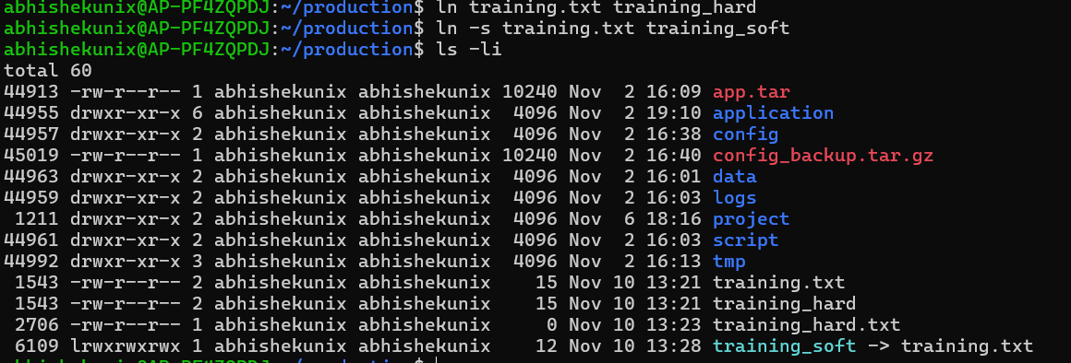
4. Modify training.txt and check both links.
If we rename the file, the hard link still exists and works
the soft link gives the error.
5. Delete training.txt.

6. Check what happens to the hard link and soft link.
7. Find the inode number of the hard link.
1543
Questions:

What is the difference between hard link and soft link?
Hard link creates a replica of the original file, if original file is deleted, the hard link still works. The inodes value for hard link is same as the source file
Soft link creates a shortcut to the file, it has it own inode value. If the original file is deleted, the soft link stops working as well.
Why does the hard link still work after deleting the original?
Hard link creates a replica of the original file, if original file is deleted, the hard link still works.

Why does the soft link become broken?
Soft link creates a shortcut to the file, hence if the file is deleted the shortcut also stops working as well

Assignment - 2 â€” cut:
---------------------

Create this file:

101,Chenna,DevOps,85000
102,Rahul,Testing,65000
103,Priya,Development,90000
104,Amit,DevOps,95000
105,Sneha,Support,55000

Save it as:

employees.txt

- Display only employee IDs.
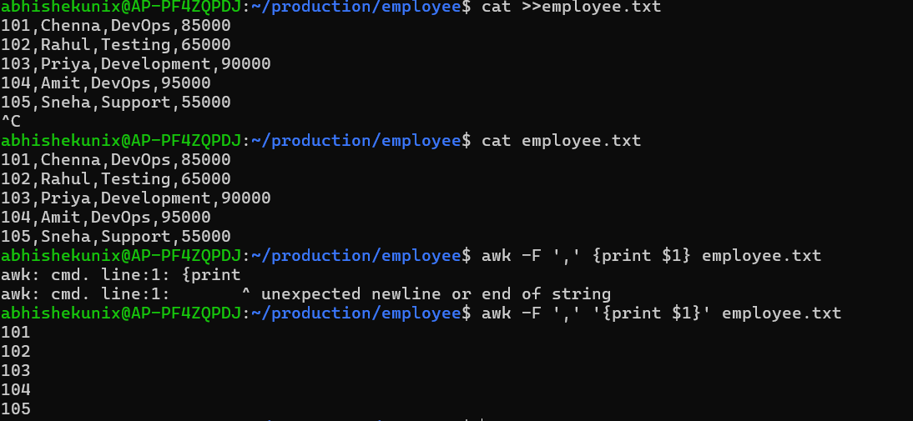
- Display only employee names.
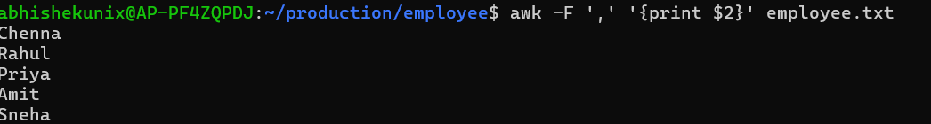
- Display only department names.
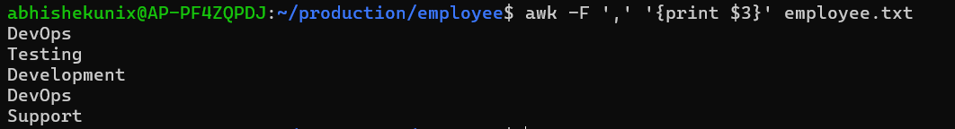
- Display only salaries.
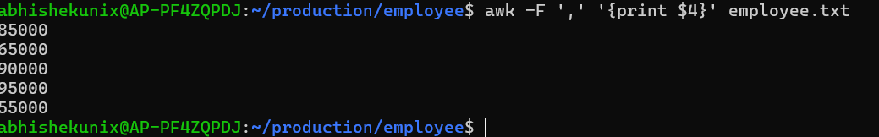
- Display name + department.
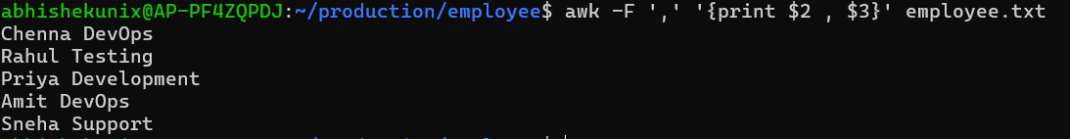
- Display name + salary.
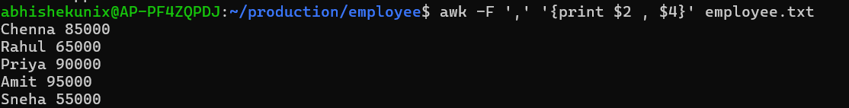
- Display the first 2 fields.
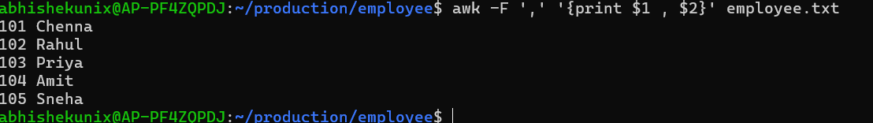
- Display the last field.
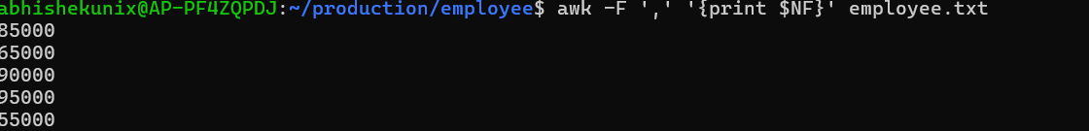
- Display employee names and salaries separated by -.
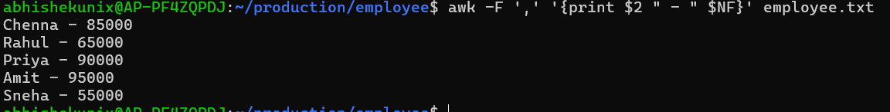
10.Display as shown below format:

Chenna earns 85000
Rahul earns 65000
...
...
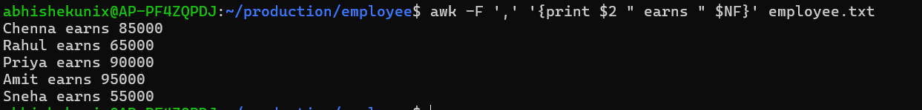
11.Print employees whose salary is greater than 80000.
12.Print employees working in DevOps.
13.Count the number of employees.
14.Calculate the total salary.
15.Calculate the average salary.
Assignment - 3 â€” Real-World Log Analysis:
-----------------------------------------

Create access.log with below content:

192.168.1.10 - - [12/Sep/2026:10:15:20] "GET /index.html" 200 1200
192.168.1.20 - - [12/Sep/2026:10:16:10] "GET /login" 200 800
192.168.1.10 - - [12/Sep/2026:10:17:30] "POST /login" 401 500
192.168.1.30 - - [12/Sep/2026:10:18:40] "GET /products" 200 2400
192.168.1.20 - - [12/Sep/2026:10:19:50] "GET /admin" 403 600
192.168.1.40 - - [12/Sep/2026:10:20:15] "GET /products" 200 2200
192.168.1.10 - - [12/Sep/2026:10:21:25] "POST /login" 401 500
192.168.1.50 - - [12/Sep/2026:10:22:35] "GET /index.html" 200 1300
192.168.1.20 - - [12/Sep/2026:10:23:45] "GET /admin" 403 600
192.168.1.60 - - [12/Sep/2026:10:24:55] "GET /products" 500 300

Using awk, cut, sed, grep, and basic Linux commands:

- Display all IP addresses.
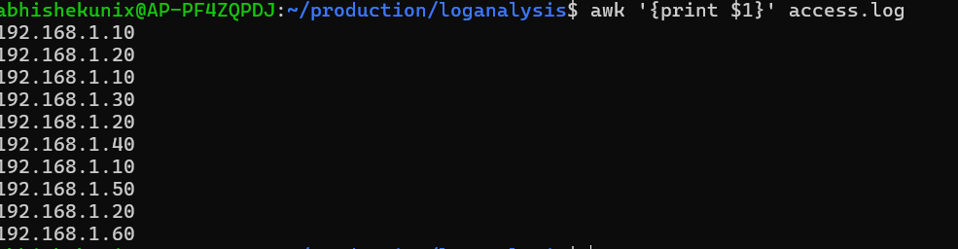
- Display unique IP addresses.
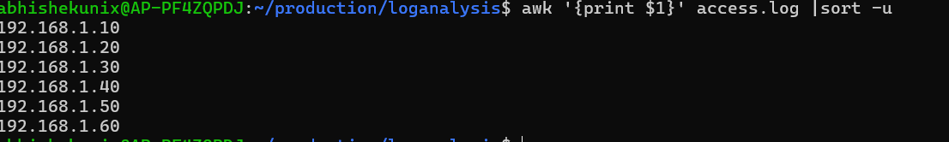
- Count requests from each IP.
awk '{print $1}' access.log | sort | uniq -c
- uniq identifies consecutive duplicate lines.
- -c counts how many times each IP appears.
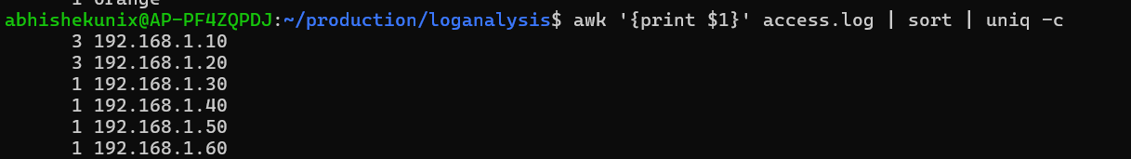
- Find the IP generating the most requests.
awk '{print $1}' access.log | sort | uniq -c | awk 'NR==1 {max=$1} $1==max'
- Display all HTTP status codes.
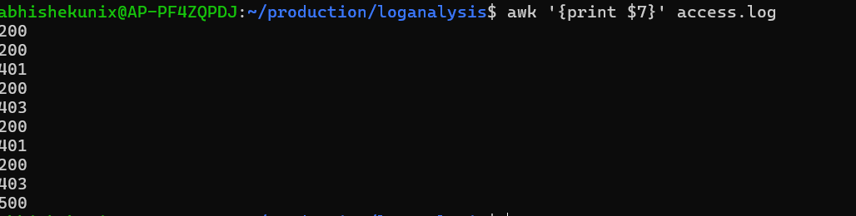
- Count how many requests returned 200.
awk '$7 =="200" {count++} END {print count}' access.log
7. Count how many requests returned 401.
8. Count how many requests returned 403.
9. Count how many requests returned 500.
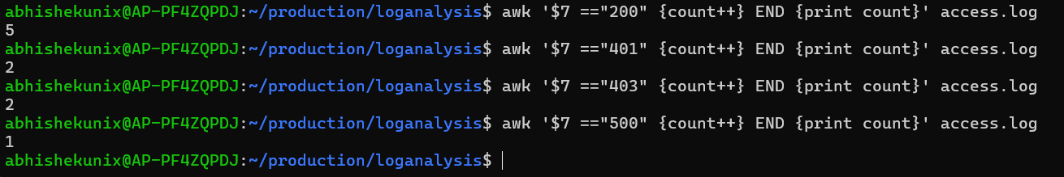
10.Display only failed requests.
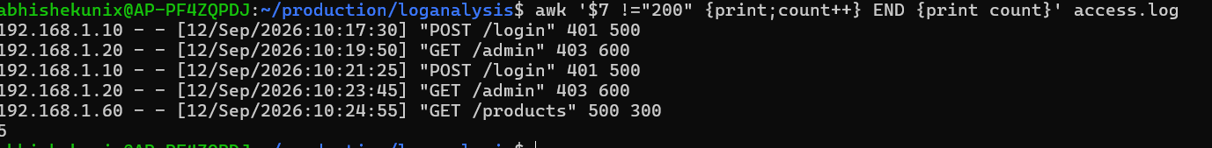
11.Display all requests to /admin.
12.Find the number of /products requests.
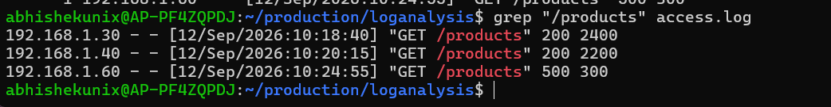
13.Calculate the total response size.
14.Find the largest response size.
awk 'NR==1 || $8 > max {max=$8} END {print max}' access.log
- NR==1 – Checks whether this is the first record.
- $8 > max – Checks whether the current response size is greater than the stored maximum.
- {max=$8} – Stores the largest response size found so far.
- END – Executes after processing all records.
- print max – Displays the largest response size.

15.Find the IP addresses generating 401 responses.
16.Find IPs generating 403 responses.
17.Replace /admin with /secure-admin using sed.
18.Replace HTTP 500 with ERROR.
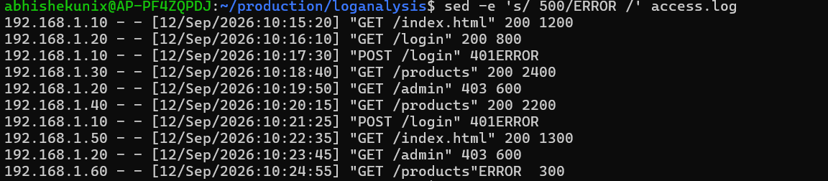
19.Replace HTTP 200 with SUCCESS.
20.Generate a report like:
===== ACCESS LOG REPORT =====

Total Requests : 10
Successful : 6
Unauthorized : 2
Forbidden : 2
Server Errors : 1

